Group Members:
Christie Chong (cchong@mit.edu), 15.8731
Catherine DiGennaro (cdigenna@mit.edu), 15.873
Aaliya Hussain (ahsn@mit.edu), 15.8731

A1
Test Case: 20% step in customer orders in week 5
Inventory (Widgets) |  | Production Start Rate (Widgets/Week) |  | Production Rate (Widgets/Week) |  | Amplification Ratio | Oscillation Period | Settling Time
Min | Max | Min | Max | Min | Max | Amplification Ratio | Oscillation Period | Settling Time
31639.2 | 47999.5 | 12000 (after pulse) | 14238.4 | 12000 (after pulse) | 12967.6 | 1.5 | N/A | ~27 weeks

After a 20% step increase in the Customer Order Rate in week 5, Expected Customer Orders begin to rise; expectations do not meet the actual orders for some time due to a delay in this information being processed by the decision makers (Figure 1). The influx of orders does lead to an immediate depletion of on-hand Inventory, which coincides with an increased Shipment Rate as the company fills all the orders it can. Decreased Order Fulfillment Ratio and Shipment Rate follow shortly thereafter due to the depleted Inventory; because this model assumes that there are multiple SKUs, simply having the number of units on hand is not enough to fulfill all orders as it is assumed that some product types are out of stock and some orders may not be filled.
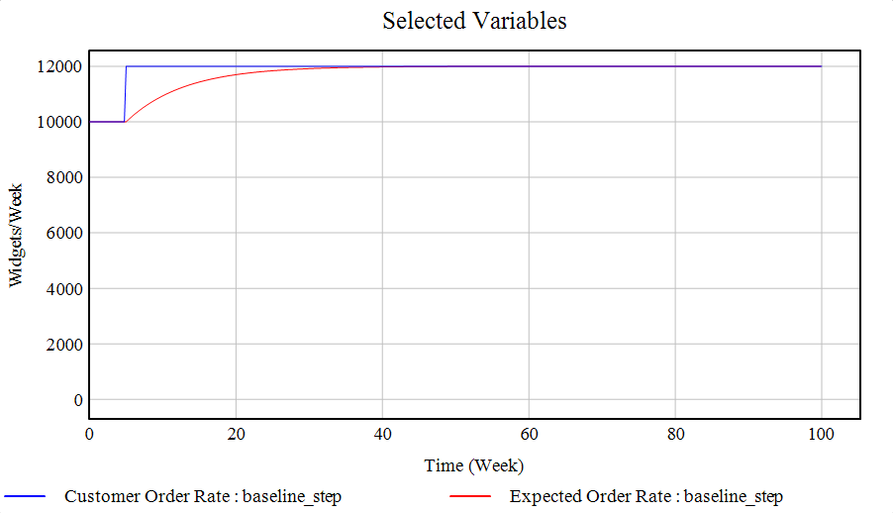
Figure 1: Actual Customer Orders vs. Expected Customer Orders

After the informational delay passes, once decision-makers’ Expected Customer Orders begin to match the Actual Customer Orders, Production Start Rate increases to compensate for the inventory depletion and adjust to the slowly increasing expectations of future customer orders, and Work-In-Progress (WIP) Inventory begins to increase as a result. Then, after another delay, which is associated with the Manufacturing Cycle Time, Production Rate begins to increase. Production Start Rate, Production Rate, and WIP Inventory all exceed the 20% increase in actual customer orders, with Production Start Rate experiencing the largest excess. As the gap between expected and actual customer orders closes, Production Start Rate approaches its new equilibrium value (i.e., 20% higher than the start), and Production Rate overtakes Production Start Rate before it also declines, along with the WIP Inventory, to a new equilibrium value that reflects the 20% step in Customer Order Rate. The 20% step also causes the Desired Inventory Coverage to increase, leading to an increase in the Desired Inventory. Inventory never overshoots the new equilibrium value, but instead steadily increases to a new equilibrium value after its initial decrease (Figure 2). Shipment Rate recovers relatively quickly as new inventory is produced, which causes Order Fulfillment Ratio to return to 1 (i.e., all orders are fulfilled).
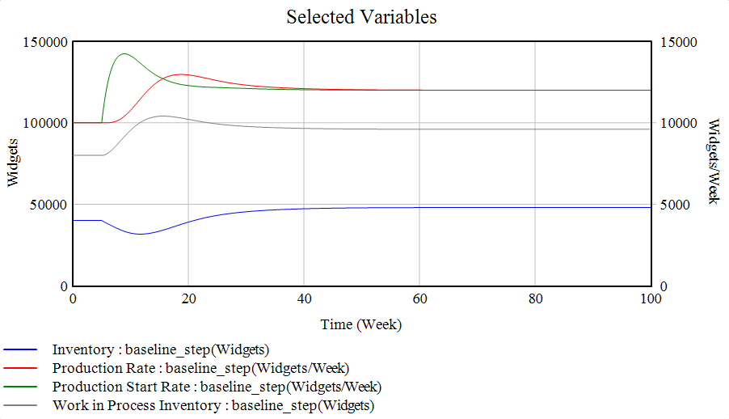
Figure 2: Production and Inventory

Figure 3 shows the relationship between Inventory and Production Start Rate over the course of the system’s adjustment to the 20% step in Customer Order Rate. The arc that spans the Inventory values of 32,000 to 40,000 widgets represents the initial overshoot in the Production Start Rate, which was caused by the depletion of Inventory to meet the sudden increase in actual orders. The fairly flat portion of the graph demonstrates the decline of the Production Start Rate to its equilibrium value as the Inventory was replenished.
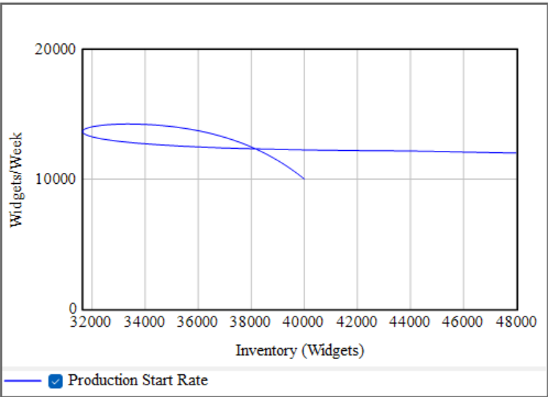
Figure 3: Phase plot between Inventory and Production Start Rate

A2
Part A
The magnitude of the change in the Production Start Rate is greater than the magnitude of the change in the Customer Order Rate. Quantitatively, the amplification ratio is 1.5, which is greater than 1, demonstrating an amplification of the change in Production Start Rate relative to the change in Customer Order Rate.

Part B
Amplification occurs due to the sudden nature of the increase in Customer Order Rate and to the delays in manufacturing enough widgets to meet the increased demand. Because the Customer Order Rate increases by 20% suddenly, Inventory is depleted, and the Order Fulfillment Rate falls below 1. Once decision-makers begin to perceive the increase in Customer Order Rate, Production Start Rate must be increased beyond the rate needed to meet the new demand in order to replenish the depleted inventory. Delays in the manufacturing process further contribute to the amplification by lengthening the period in which Inventory is depleted.

Part C
The magnitude of amplification depends on Inventory Adjustment Time, WIP Adjustment Time, Safety Stock Coverage, Manufacturing Cycle Time, and Time to Average Order Rate.

As Inventory Adjustment Time increases, the time needed to respond to a change in inventory increases, and the response to the change in customer demand is dampened. Production Start Rate increases more slowly, reaches a lower maximum value, and is less likely to repeatedly undershoot and overshoot. Greater oscillatory behavior is observed with shorter Inventory Adjustment Times because the inventory control balancing feedback mechanism involves two other delays (the WIP Adjustment time and the Manufacturing Cycle Time), which means that adequate time must pass between adjustments to the Production Start Rate from Inventory to allow for the other delays to pass.

The opposite relationship is observed between the length of the WIP Adjustment Time and the stability of the Production Start Rate. As WIP Adjustment Time increases, greater oscillatory behavior is observed in the Production Start Rate. Unlike the inventory control balancing feedback mechanism, the WIP control feedback mechanism involves no delays other than the WIP Adjustment Time. Shortening the WIP Adjustment Time thus hastens the adjustment to the Production Start Rate from WIP Inventory, stabilizing the system’s behavior because no other delays must pass.

As Safety Stock Coverage increases, greater amplification in the Production Start Rate is observed because the greater the desired weeks of safety stock, the greater the Production Start Rate that is required to maintain the safety coverage after an increase in customer demand.

An increase in the Manufacturing Cycle Time leads to an amplification in production and inventory levels. This is because it takes longer for the Inventory to reflect changes in the production rate, and the Desired WIP increases in response to an increased Manufacturing Cycle Time to account for this, which can lead to oscillatory behavior as production overshoots and undershoots. Decreasing the Manufacturing Cycle Time, on the other hand, makes the production rate faster and reduces the compensatory element of Desired WIP, resulting in a reduced Production Start Rate.

The effects of the length of the Time to Average Order Rate on the amplification in the Production Start Rate are similar to those of the length of the Inventory Adjustment Time. Decreasing the Time to Average Order Rate means that changes in customer demand are perceived relatively more quickly, which increases the adjustment to the Production Start Rate from Inventory because decision makers are more reactive to the changes in the Customer Order Rate. Due to the presence of multiple delays within the inventory control balancing mechanism, high reactivity in inventory adjustment creates more oscillatory behavior.

A3
(The model results stop changing as a result of decreasing the time step at 0.01, so the model time step should be 0.01.)

The model oscillates endogenously in three scenarios. First, decreasing Inventory Adjustment Time below a period of approximately 3 weeks generates oscillations that amplify over time. Second, increasing Manufacturing Cycle Time beyond approximately 16 weeks leads to oscillations that dampen over time. Notably, changing Inventory Adjustment Time and Manufacturing Cycle Time in the same direction decreases the magnitude of the oscillatory behavior and stabilizes the system. Finally, increasing WIP Adjustment Time beyond approximately 20 weeks leads to a two period oscillation of lesser magnitude than the oscillations produced by changing Inventory Adjustment Time or Manufacturing Cycle Time; after two periods, these oscillations stabilize.

A4
The parameter values needed to reach these oscillations are likely unrealistic. For example, Inventory Adjustment Time would have to be ¼ or less of the Manufacturing Cycle Time (2 weeks) to generate constant oscillations, and no firm would reasonably expect inventory to adjust in a significantly shorter period of time than their manufacturing period. Conversely, WIP Adjustment Time has to be very long to cause oscillations (significantly longer than the Manufacturing Cycle Time). No firm would be likely to adjust WIP over a period of time much longer than their manufacturing cycle time

B1
Adjustment to Labor Force=Authorized Labor Force-Labor Force
Units: Worker
The number of workers needed to reach desired employment level is equal to the difference between the number of workers needed to meet the desired production level and the current labor force.

Attrition Rate=Labor Force/Average Worker Tenure
Units: Worker/Week
Number of workers who leave the company each week. Workers stay on average 50 weeks (1 year).

Authorized Labor Force= INTEG (Workforce Request Approval Rate,Factory Labor Request)
Units: Worker
Number of workers authorized to be hired

Average Worker Tenure=50
Units: Weeks
The average worker tenure is 50 weeks (approximately 1 year).

Desired Production Start Rate = Desired Production + Adjustment for WIP
Units: Widgets/Week
The desired rate of production starts, equal to the desired production rate adjusted by the adequacy of the WIP inventory.

Factory Labor Request=MAX(0,Desired Production Start Rate/Normal Labor Productivity)
Units: Worker
Labor request depends on desired production and current productivity

Hiring Rate=MAX(0,(Adjustment to Labor Force/Time to Adjust to Authorized Employment Level) + Attrition Rate)
Units: Worker/Week
Rate at which workers are hired

Labor Force= INTEG (Hiring Rate-Attrition Rate,Factory Labor Request)
Units: Worker
Number of workers

Normal Labor Productivity=20
Units: Widgets/Worker/Week
Average productivity for a normal worker

Normal Production Rate=Labor Force*Normal Labor Productivity
Units: Widgets/Week
Normal rate of widget production per week

Production Start Rate=MAX(0,Normal Production Rate)
Units: Widgets/Week
The production start rate is the desired production start rate, constrained to be nonnegative.

Time to Adjust to Authorized Employment Level=8
Units: Week
Time needed for company to adjust to authorized employment level. Given at 8 weeks.

Time to Authorize Labor Changes=4
Units: Week
Time needed to approve requested changes in the labor force. Given at 4 weeks.

Workforce Request Approval Rate=(Factory Labor Request-Authorized Labor Force)/Time to Authorize Labor Changes
Units: Worker/Week
Rate at which requested adjustments to the labor force are approved, less what has already been authorized

B2
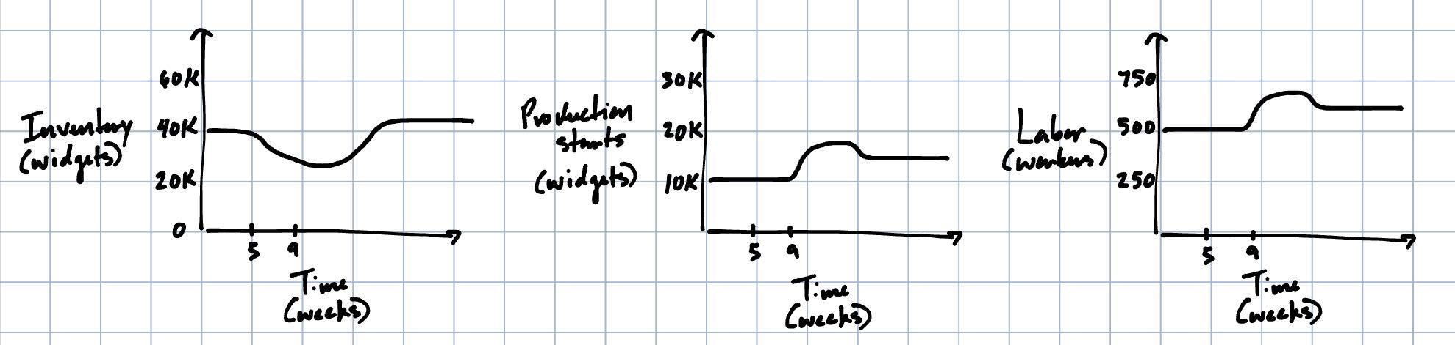
Notes: We predict that the increase in product starts will be in-phase with the increase in the labor force because the labor force is now the limiting factor for the Production Start Rate. Inventory is expected to undershoot at a greater magnitude and start recovering later as the Production Start Rate now cannot increase instantaneously due to the delays in adjusting the labor force.

B3
Part A
Plot of Customer Order Rate, Expected Order Rate, Desired Production, Desired Production Start Rate, Production, and Production Start Rate
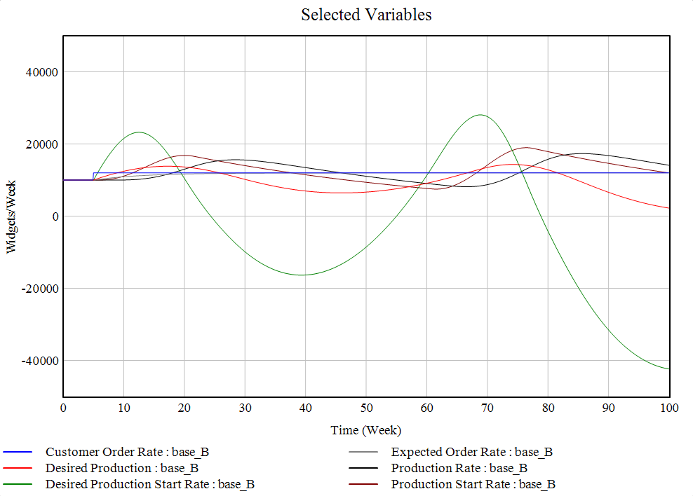
Note: The large oscillations in the Desired Production Start Rate are due to the large oscillations in the adjustments from WIP, and the oscillatory behavior of the adjustment from WIP is caused by a balancing feedback mechanism that attempts to eliminate the gap between the actual and desired level of Inventory.

Part B
Plot of Desired Inventory and Inventory
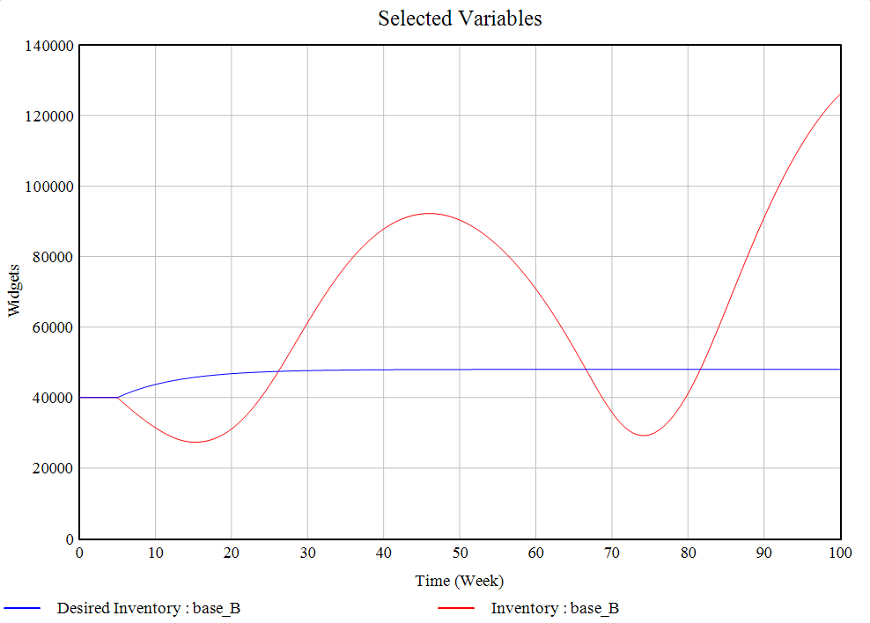
Note: The large oscillations in Inventory are due to the presence of multiple delays in the balancing feedback mechanism that seeks to close the gap between Desired Inventory and Inventory.

Plot of Desired WIP Inventory and WIP Inventory
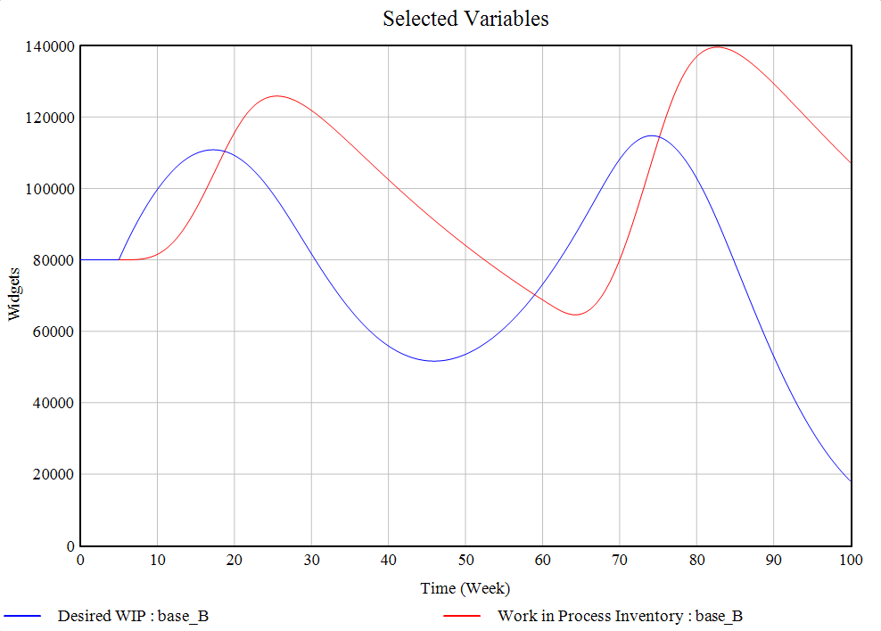
Note: The oscillations in WIP Inventory lag the oscillations in Desired WIP Inventory because of the delays in adjusting the Production Start Rate, which are caused by the delays in the labor force control process.

Part C
Plot of Labor and Factory Labor Request
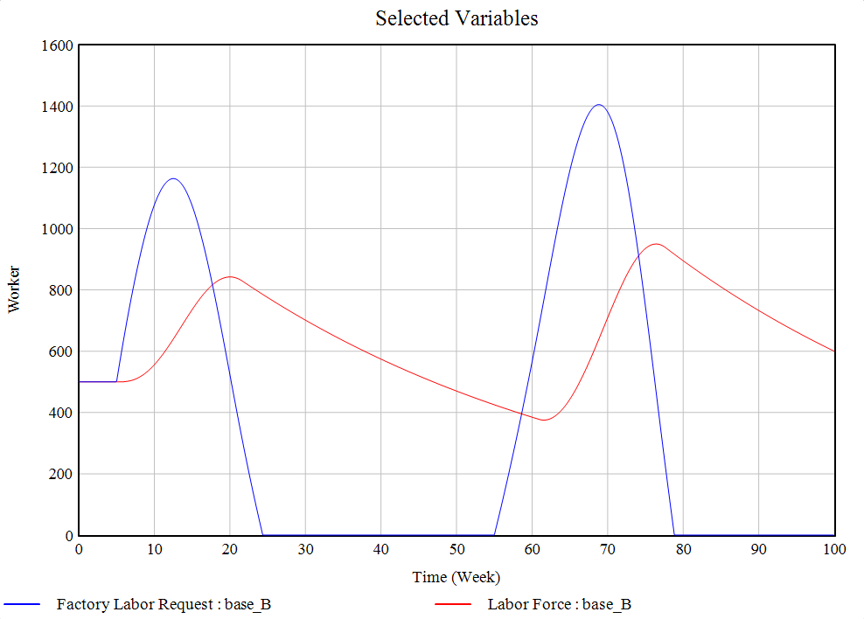
Note: The oscillations in Factory Labor Request and Labor Force due to the numerous delays involved in the balancing feedback mechanism that controls Labor Force, and the lag in the Labor Force oscillations relative to the Factory Labor Request oscillations is specifically caused by the delay in authorizing labor requests.

Part D
Plot of Inventory Coverage and Order Fulfillment Ratio
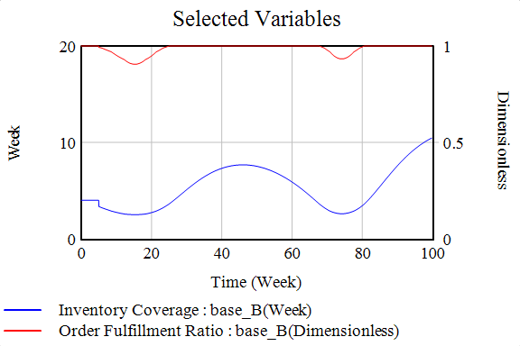
Note: The Order Fulfillment Ratio drops below 1 (i.e., not all customer orders can be fulfilled) if the inventory coverage dips below the critical threshold of 4 weeks.

Part E
Phase Plot of Labor vs. Inventory
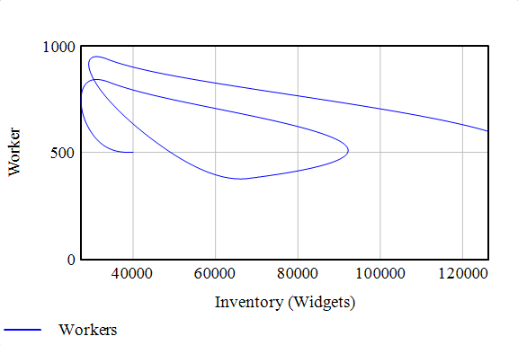
Note: The swirls reflect the oscillatory modes of behavior in both Labor Force and Inventory, which are fundamentally caused by the delays in the labor control balancing mechanism.

B4
When Customer Order Rate increases by 20% at week 5, Inventory depletes to meet the sudden surge in demand, and Desired Production Start Rate increases in response to the declines in Inventory. Because Production Start Rate is constrained by the Labor Force, to actually increase Production Start Rate to the desired level, additional labor must be acquired. The labor acquisition process involves two delays: Time to Authorize Labor Changes, which is approximately 4 weeks, and Time to Adjust to Authorized Employment level, which is approximately 8 weeks. Due to the delays, at any given time, Labor Force and thus Production Start Rate only fully adjusts to adjustments from Inventory after approximately 12 weeks.

Inventory begins to be replenished around 15 weeks, once Production Start Rate and Production Rate begin increasing after some of the labor delays pass. As Inventory begins to approach Desired Inventory, the adjustment to Desired Production Start Rate from Inventory diminishes, leading to a decrease in Factory Labor Request that must propagate through the time-delayed Labor Force control mechanism. Because of the delays in updating Labor Force and Production Start Rate, WIP Inventory only peaks once Inventory reaches Desired Inventory at around 27 weeks, meaning that Inventory overshoots Desired Inventory rather than reaching an equilibrium.

These delays also generate an overshoot in Production Rate. Because of the delay in the peak of WIP Inventory, Production Rate continues to increase even as it surpasses Shipment Rate and will not begin to decrease until approximately 12 weeks after it was already sufficient, or after the delays in the Labor Force control mechanism pass. The same delays lead to an undershoot in Production Rate, which causes an undershoot in inventory. The signals to decrease the Production Rate via decreases in Factory Labor Requests and Production Start Rate only fully propagate once they are no longer relevant (i.e., once the Production Rate has already begun to decline), which causes another adjustment to increase the Production Start Rate to be signaled before the system can reach equilibrium.

In summary, the delays in the balancing feedback mechanism that controls the Labor Force generate the oscillatory modes of behavior in the various stocks of the model. Because adjustments to Production Start Rate and Factory Labor Request are continuously made before the system can reach equilibrium after previous adjustments, the stocks constantly overshoot and undershoot.

B5
Part A
The amplification factor of the changes in Production Start Rate versus the changes in Customer Order Rate is approximately 5.5, which indicates that the magnitude of the changes in the Production Start Rate is much greater than the magnitude of the changes in Customer Order Rate.

Part B
The new amplification factor of 5.5 is much larger than the amplification factor of 1.5 observed in the model without the labor component. The increase in the amplification factor is caused by the time delays in the balancing mechanism that adjusts Labor Force (and Production Start Rate) to the Desired Production Start Rate.

Part C
The new sources of amplification are the delays for authorizing factory labor requests (i.e., Time to Authorize Labor Changes) and for allowing new hires to adjust to the workforce (i.e., Time to Adjust to Authorized Employment Level). Because the Production Start Rate is constrained by the Labor Force, delays in the Labor Force control mechanism create oscillations when adjustments to the Labor Force are continuously made before adequate time is given to allow the delays to pass and the system to return to equilibrium. The 12-week combined length (4 weeks from Time to Authorize Labor Changes and 8 weeks from Time to Adjust to Authorized Employment Level) is substantial relative to the other existing delays, leading to oscillations with higher amplifications.

C
Part A
We define “stability” as follows:
- Since Inventory is the key determinant of customer service (i.e., Order Fulfillment Ratio), in a stable system, the magnitudes of deviations between Inventory and Desired Inventory are small.
- Oscillations experience low amplification throughout the system (i.e., all amplification factors are close to 1), and fluctuations have short periodicity.
- The system returns quickly to a “sticky” (i.e., stable) equilibrium.

Part B
We predict that increasing Time to Adjust Inventory will stabilize the system by allowing the various delays in the manufacturing control mechanisms to pass before additional adjustments are made.

Part C
Our intuition is correct. Increasing Time to Adjust Inventory decreases the amplitude of oscillations, meaning that it stabilizes the system. As mentioned above, a longer Time to Adjust Inventory allows for greater time to pass before adjustments are made to Desired Production Start Rate, which initiates the time-delayed balancing feedback mechanisms for Labor Force, WIP, and Inventory Control, and allows the system to return closer to equilibrium between adjustments.

Part D
WIP Adjustment Time
Prediction: Decreasing WIP Adjustment Time should make the system more stable.
Model outcome: Our intuition is incorrect. A shorter WIP Adjustment Time, or a highly reactive WIP Inventory management policy, destabilizes the system by causing adjustments to Labor Force from WIP Inventory to be made before the delays in the Labor Force control process can pass.

Time to Authorize Labor Changes
Prediction: Decreasing Time to Authorize Labor Changes should make the system more stable.
Model outcome: Our intuition is correct. A shorter Time to Authorize Labor Changes reduces the delays in the Labor Force control mechanism, meaning that the system can more quickly return to equilibrium after adjustments are made to the Labor Force.

Time to Adjust to Authorized Labor Changes (i.e., Time for Incremental Hires)
Prediction: Decreasing Time to Adjust to Authorized Labor Changes should make the system more stable.
Model outcome: Our intuition is correct. Similar to Time to Authorize Labor Changes, a shorter Time to Authorize Labor Changes reduces the delays in the Labor Force control mechanism, meaning that the system can more quickly return to equilibrium after adjustments are made to the Labor Force.

Manufacturing Cycle Time
Prediction: Decreasing Manufacturing Cycle Time should make the system more stable.
Model outcome: Our intuition is correct. Analogous to the labor-associated delays, a shorter Manufacturing Cycle Time reduces the delay in the balancing mechanism controlling Inventory, meaning that the system takes less time to return to equilibrium after adjustments are made to Inventory.

Takeaway: The key determinant of the system’s stability is the ratio of the time required for the system to return to equilibrium and the time between adjustments to the system. The smaller the ratio (i.e., the less time the system takes to return to equilibrium relative to the time between adjustments), the more stable the system, and vice versa. The parameters that decrease the time for the system to return to equilibrium, Time to Authorize Labor Changes, Time to Adjust to Authorized Labor Changes, and Manufacturing Cycle Time, should all be decreased while the parameters that increase the time between adjustments to the system, Time to Adjust Inventory and WIP Adjustment Time, should all be increased.

Part E
Based upon the above analysis, the following policies should be adopted to increase the stability of the system:
The time required to adjust the workforce should be shortened via two major levers: the time required to authorize factory labor requests and the time required for new hires to adjust to the working environment. Factory labor requests can be processed more rapidly through actions like increasing the number of staff who are capable of authorizing the requests and reducing the bureaucratic requirements for approving the requests. The time necessary for new hires to acclimate to the working environment could be shortened by improvements to the onboarding and training process and selection of candidates with prior manufacturing experience.

The time between adjustments to the system can be lengthened if decision-makers are less reactive to changes in WIP and finished-goods inventory. Managers can be instructed to call for adjustments at lower frequencies (i.e., increasing a minimum threshold for time between changes) or at higher magnitudes of changes (i.e., increasing a minimum threshold for changes in customer orders).

D1
Part A
The general relationship between schedule pressure and workweek is characterized by a “no undertime” rule, even if schedule pressure approaches zero, i.e., there is no need for production. As schedule pressure increases past the normal level of 1, workweek increases by a decreasing rate such that a maximal increase of 1.3 times the normal workweek is asymptotically reached when the schedule pressure reaches twice its normal value. This maximal increase in the workweek may represent some legal or internal policy on the maximum permissible workweek.

Part B
The line Relative Workweek = 1 means that the workweek is constant at its normal value regardless of any changes to schedule pressure. This represents a completely inflexible workweek policy.

Part C
The line Relative Workweek = Schedule Pressure means that workweek varies at a 1:1 ratio with schedule pressure, i.e., any change in schedule pressure will cause an equivalent change in workweek, regardless of the level of the change. At the extremes, a schedule pressure of zero would lead to a work stoppage and a schedule pressure of 2 (or greater) would lead to a doubling (or greater) of workweeks for existing employees.

D2
Flexible workweeks firm stabilize the system. Allowing for flexibility in workweeks effectively buffers the system from high reactivity to changes in Customer Order Rate. Because workweek can be adapted to Schedule Pressure without any significant delays, flexible workweek policies create a margin by which Production Start Rate can be quickly altered before time-delayed changes to Labor Force are required.

E1
Part A
Implementing the following policies would stabilize the oscillations in the system.

First, management could consider ways to promote a more nimble workforce, including by decreasing delays in workforce approval. This could be accomplished by increasing the efficiency of the management level approval decisions involved such that decisions do not go through as many layers of management. Identifying the set of people whose decisions are critical and excluding those whose input is not relevant to the overall decision from the approval process may help achieve this. Reducing the delays in the hiring process, e.g., by prioritizing candidates who are available more immediately, or who need less training because they have prior experience, would also help reach this goal. The hiring delay can be further reduced by streamlining the interview process such that the maximum proportion of the hiring committee’s time is spent on promising candidates. Another way to promote a nimble workforce is to allow for more flexible workweeks; when less production is needed, workers can be scheduled for fewer hours, and vice versa. This does not have to entail an entirely reactive scheduling system, but adjusting for demand will reduce oscillation in the system.

Second, management could smooth oscillations by decreasing their reactivity to changes in demand. This could be accomplished by implementing a minimum “reaction time” over which decision makers can remain relaxed about production levels and change them more slowly in response to changes in demand.

Finally, where possible, additional efficiency should be sought in the manufacturing process. This would help achieve stability in two ways; first, by decreasing the manufacturing time, inventory levels would more quickly respond to changes in production, sending an earlier signal about whether production levels should be adjusted. Second, decreasing the manufacturing time reduces the production needed because if it is known that production is relatively faster, today’s production can cover less of the future demand and production can shift to a more agile model.

Part B
Purpose | Parameter | Rationale | Base Case | Policy Value
Decrease delays in authorizing changes to the workforce | Time to Authorize Labor Changes | This parameter has an inverse relationship with the workforce request approval rate and so the approval rate can be directly influenced by changing this parameter. | 4 weeks | 2 weeks
Decrease delays in the hiring process | Time to Adjust to Authorized Employment Level | This parameter has an inverse relationship with the hiring rate and thus the hiring rate can be changed directly using this parameter. | 8 weeks | 4 weeks
Allow for more flexible workweeks | Table for Relative Workweek | This parameter directly influences the relative workweek in response to schedule pressure. Giving schedule pressure more influence over workweek serves to increase workweek flexibility. | Workweek = 1, regardless of Schedule Pressure | Workweek changes symmetrically to allow for under- and overtime in response to schedule pressure. 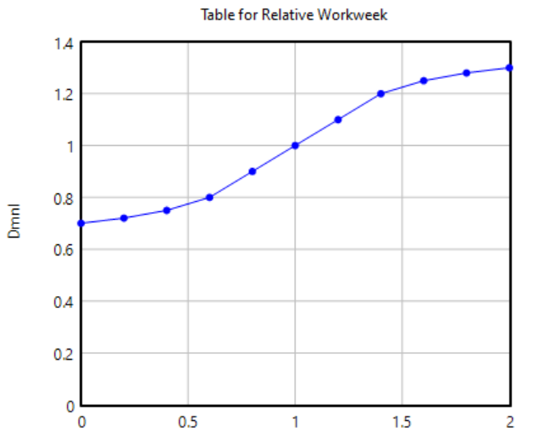
Decrease production reactivity to changes in customer demand | WIP Adjustment Time | This parameter is inversely related to the production start rate (as long as the table for relative workweek function is strictly increasing, as above), so increasing it decreases the production start rate, which is useful when customer orders have increased and production start rate would otherwise be higher. | 2 weeks | 4 weeks
Increase efficiency in the manufacturing process | Manufacturing Cycle Time | This parameter is inversely related with the production rate and inversely related with production start rate, so efficiency can be increased via two channels by changing this parameter - speeding up production rate and slowing down production start rate, which allows more time for smoothing the production patterns. | 8 weeks | 4 weeks

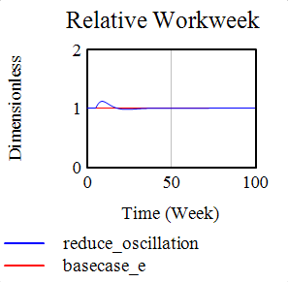
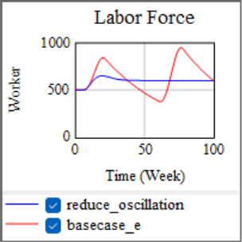
E2
*bold text refers to figures at right
Implementing the changes in the table above does achieve oscillation reduction. Most of the reduction comes from the schedule flexibility policy, and only changing this parameter as specified does eliminate most of the oscillatory behavior in the system.
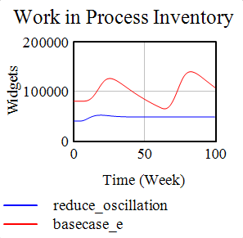
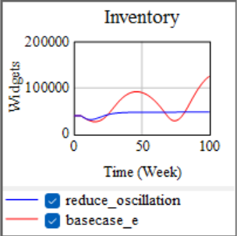
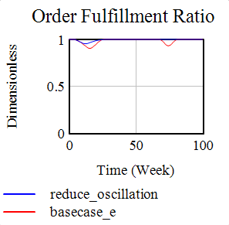
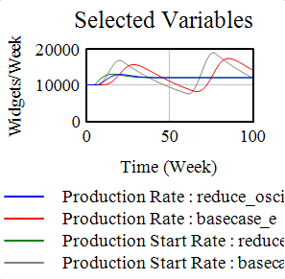
This set of policies reduces the need to make large adjustments to the labor force to meet increased demand because with the possibility of under- or overtime, changes in production can be achieved with the existing workforce, so Relative Workweek is variable with the new policy. When changes to the workforce are needed, as in the beginning when inventory is initially depleted, reduced delays for labor authorization and hiring mean that this workforce adjustment can be achieved more quickly (Labor Force).

Additionally, manufacturing is more efficient, reducing the amount of time needed for units to remain in WIP Inventory before they are available as Inventory, strengthening the balancing Inventory Control mechanism and reducing Production Start Rate and Production Rate such that they are equal after a short period rather than continuously out of sync (see Selected Variables). Also reducing Production Start Rate over the whole period is the reduction in WIP Adjustment Time.

These adjustments allow for a higher overall Order Fulfillment Ratio; facing the initial inventory depletion, the OFR still drops, but by less because workers adjust to the increased production needs with overtime rather than having to wait for additional hires to arrive. OFR drops ~week 75 in the base case scenario, but remains constant at 1 with the oscillation reduction policy in place.

